Supplementary Materials

a) 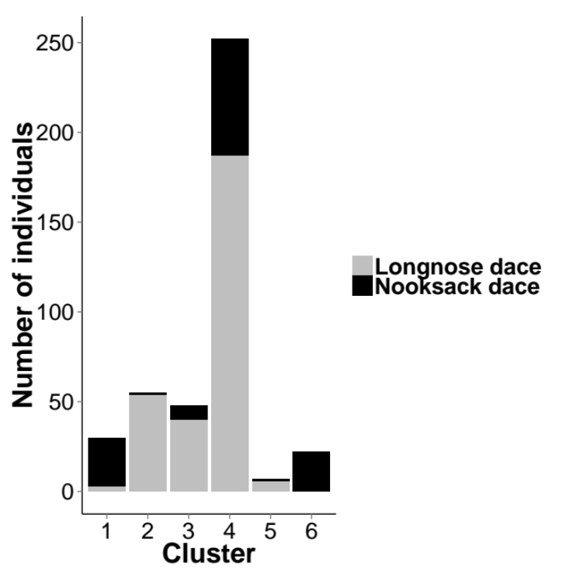b) 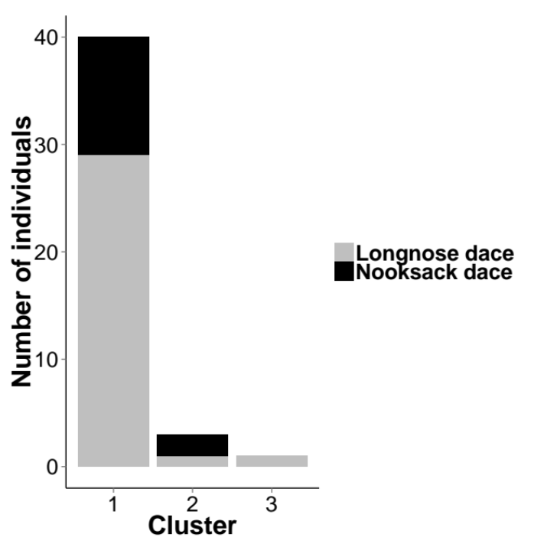

Figure S1. Stacked bar chart showing the mtDNA composition of each morphological cluster generated by the mclust analysis conducted on (a) allopatric longnose dace and Nooksack dace (Rhinichthys cataractae) (N = 414), and (b) longnose dace and Nooksack dace from Kanaka Creek (N = 44). Each column represents one cluster (cluster number indicated at the bottom). The colours indicate the proportions of each mtDNA group that were found within each morphological cluster: Nooksack dace (black) and longnose dace (grey).
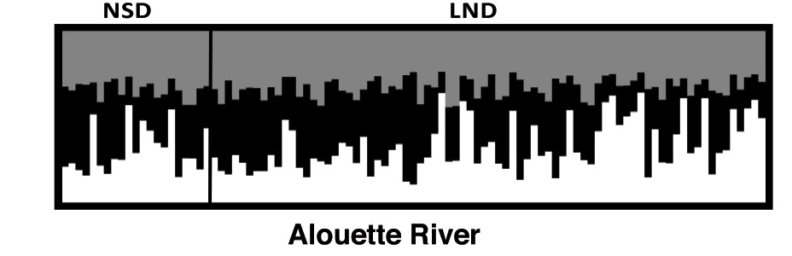

Q

Figure S2. Output of Structure run showing admixture analysis with K= 3 from 10 microsatellite DNA loci in 99 Rhinichthys cataractae from the Alouette River, a site sympatric for longnose and Nooksack mtDNA haplotypes. Each fish is represented by a thin vertical line and each colour represents the proportional contribution (Q) to the genome of each fish by one of three genetic groups (white, black and grey). Samples are arranged by mtDNA type separated by the thick vertical black line, with NSD on the left (N = 25) and LND on the right (N = 74).
Table S1. List of sampling locations for Nooksack dace and longnose dace (Rhinichthys cataractae) used in morphological analyses. Catalogue no. refers to the catalogue of the Beaty Biodiversity Museum (University of British Columbia). N denotes number of fish from that collection that were measured.

Catalogue No. | Allopatric / Sympatric | Species Present | Location | Location Code | Site No. | Latitude | Longitude | Collection Date | N
BC80-0084 | A | NSD | Wynoochee River, WA, USA | WY | 1 | 46.98069 | 123.6464 | 25/03/1975 | 13
BC80-0093 | A | NSD | Wynoochee River, WA, USA | WY | 2 | 46.98069 | 123.6464 | 25/04/1975 | 15
BC66-0096 | A | NSD | Willapa River, WA, USA | WP | 1 | 46.56001 | 123.5602 | 31/08/1961 | 13
BC06-0236 | A | NSD | Willapa River, WA, USA | WP | 2 | 46.53591 | 123.46143 | 27/07/1990 | 4
BC11-0539 | A | NSD | West Fork Satsop River, | SR | 1 | 47.05983 | 123.541 | 12/08/2007 | 26
BC11-0539 | A | NSD | WA, USA
BC11-0544 | A | NSD | Porter Creek, WA, USA | PC | 1 | 46.94645 | 123.29543 | 13/08/2007 | 5
BC11-0018 | A | NSD | Willamette River, WA, USA | WR | 1 | 43.80578 | 123.05827 | 21/09/1994 | 7
BC76-0038 | A | NSD | Cowlitz Rver, WA, USA | CW | 2 | 46.35624 | 122.93204 | 18/02/1961 | 4
BC11-0418 | A | NSD | Cowlitz Rver, WA, USA | CW | 1 | 46.30808 | 122.92053 | 30/08/1958 | 15
BC11-0019 | A | NSD | Brunette River, BC, Canada | BR | 1 | 49.24145 | 122.89594 | 03/06/2002 | 28
BC11-0004 | S | BOTH | Coquitlam River, BC, Canada | CR | 3 | 49.28031 | 122.77632 | 08/06/2004 | 10
BC11-0006 | S | BOTH | Coquitlam River, BC, Canada | CR | 4 | 49.32602 | 122.77153 | 31/08/2008 | 2
BC14-0018 | S | BOTH | Coquitlam River, BC, Canada | CR | 5 | 49.32602 | 122.77153 | 17/09/2012 | 2
BC11-0007 | S | BOTH | Coquitlam River, BC, Canada | CR | 3 | 49.04155 | 122.77107 | 09/07/2004 | 6
BC11-0010 | S | BOTH | Coquitlam River, BC, Canada | CR | 2A | 49.33616 | 122.76821 | 07/06/2004 | 5
BC57-0269 | A | LND | Wright Creek, BC, Canada | WC | 1 | 54.09764 | 122.68121 | 13/06/1953 | 30
BC11-0005 | S | BOTH | Alouette River North, BC, Canada | AN | 3 | 49.24242 | 122.60108 | 15/08/2004 | 7
BC14-0017 | S | BOTH | Alouette River North, BC, Canada | AN | 1 | 49.24285 | 122.57974 | 27/09/2012 | 19
BC06-0128 | S | BOTH | Alouette River North, BC, Canada | AR | 4 | 49.24159 | 122.57978 | 18/05/1994 | 27
BC11-0008 | S | BOTH | Alouette River North, BC, Canada | AR | 3 | 49.23439 | 122.60097 | 18/07/2004 | 5
BC14-0016 | S | BOTH | Alouette River North, BC, Canada | AR | 4 | 49.23918 | 122.57932 | 21/05/1976 | 1
BC11-0009 | S | BOTH | Alouette River North, BC, Canada | AR | 4 | 49.23918 | 122.57932 | 09/07/2004 | 5
BC11-0541 | S | BOTH | Kanaka Creek, BC, Canada | KC | 1 | 49.20216 | 122.54129 | 17/08/2007 | 33
BC11-0540 | S | BOTH | Kanaka Creek, BC, Canada | KC | 2 | 49.20727 | 122.5363 | 17/08/2007 | 12
BC14-0015 | S | BOTH | Kanaka Creek, BC, Canada | KC | 2 | 49.20727 | 122.5363 | 31/08/2008 | 2
BC14-0029 | S | BOTH | Kanaka Creek, BC, Canada | KC | 4 | 49.21558 | 122.52399 | 31/08/2008 | 11
BC14-0013 | S | BOTH | Kanaka Creek, BC, Canada | KC | 3 | 49.2121 | 122.50855 | 31/08/2008 | 6
BC14-0019 | S | BOTH | Kanaka Creek, BC, Canada | KC | 5 | 49.22612 | 122.46117 | 31/08/2008 | 8
BC11-0542 | A | NSD | Bertrand Creek, BC, Canada | BT | 1 | 49.00432 | 122.53217 | 19/07/2007 | 20
BC11-0020 | A | LND | Norrish Creek, BC, Canada | NC | 2 | 49.23485 | 122.13359 | 11/06/1992 | 7
BC06-0215 | A | LND | Norrish Creek, BC, Canada | NC | 3 | 49.23485 | 122.13359 | 18/05/1994 | 18
BC59-0600 | A | LND | Norrish Creek, BC, Canada | NC | 1 | 49.23581 | 122.13261 | 27/08/1955 | 6
BC59-0002 | A | LND | Coquihalla River, BC, Canada | CQ | 1 | 49.38851 | 121.43344 | 02/07/1952 | 32
BC11-0003 | A | LND | Petit Creek, BC, Canada | PT | 1 | 50.15396 | 121.03088 | 15/08/1994 | 20
BC56-0558 | A | LND | Columbia River, Big Bend region, BC, Canada | CL | 1 | 51.55186 | 118.53917 | 07/08/1952 | 30
BC11-0517 | A | LND | Beaver Creek, BC, Canada | BC | 1 | 49.06946 | 117.60099 | 04/08/2007 | 1
BC11-0516 | A | LND | Beaver Creek, BC, Canada | BC | 2 | 49.10086 | 117.55722 | 04/08/2007 | 9
BC57-0361 | A | LND | Highwood River, AB, Canada | HW | 1 | 50.80708 | 113.78779 | 15/06/1953 | 16
BC57-0362 | A | LND | Junction of Blindman & Red Deer Rivers, AB, Canada | RD | 1 | 51.35493 | 113.75697 | 16/06/1953 | 30
BC57-0357 | A | LND | Milk River, AB, Canada | MR | 1 | 49.07399 | 110.771 | 14/06/1953 | 19
BC59-0563 | A | LND | Pine River, Lake Winnipegosis, MB, Canada | PR | 1 | 52.47925 | 100.03532 | 16/10/1950 | 30
BC58-0047 | A | BND | Schoolcraft Country, MI, USA | BN | 1 | 46.07371 | 86.19049 | 06/10/1957 | 10

Table S2. Details for 10 polymorphic microsatellite loci developed for Rhinichthys cataractae. The size indicates the range of observed alleles in base pairs and includes the length of the CAG tag; N_{A} is number of alleles observed; dye indicates the fluorescent tag used to label the locus.

Locus | Sequence Forward, 5’—3’ | Sequence Reverse, 5’—-3’ | Repeat Motif | Size (bp) | N_{A} | Dye | Source
Rhca 15b | CTCACAGACTACCTGCCC | CAGAGGTCAAACAGTAGTAGG | (CTAT)12 (CTAT- CATAT)8 (CTAT)3 | 125-341 | 16 | TYE665 | Girard and Angers 2006
Rhca 16 | GAGAACGAGTGGACATCC | AGTGAGTGGTTGAGTAGG | (GA)12 GCGT(GT)12 | 110-128 | 10 | TYE705 | Girard and Angers 2006
Rhca 23 | TTCGTCCATATCTAGAGG | TCATGAATGCAGTACTGG | (CA)7(CT) 4CACT (CA)8(CT)3 | 220-262 | 8 | TYE705 | Girard and Angers 2006
Rhca 4 | ATGCATCCACCCAAACCC | AAGCTTTCAAGTAATCAGATGAGGC | ATGG | 147-163 | 5 | TYE705 | Beasley et al. 2014
Rhca 5 | TGTTTCCTTGCCTACAGCCC | AATGTTGAAATGTTGCACAAACC | ATATT | 180-210 | 7 | TYE665 | Beasley et al. 2014
Rhca 7 | ATCCTGCTGGATCCGTTGC | ATAATAGCCATGAGGGGAGTCCG | AAAG | 217-313 | 16 | TYE705 | Beasley et al. 2014
Rhca 36 | GATACACCTTCTGCGCTTGC | TGAGATGCTGCTGTGAATGC | AAAG | 215-275 | 13 | WellRed D2 | Beasley et al. 2014
Rhca 42 | GCTGCCTGGTGTAAATTATGTCC | TTACGTTACTCATGCGTTTACCC | ATCT | 196-240 | 9 | TYE 705 | Beasley et al. 2014
Rhca 43 | CAAATCCCTTTGGAAACAAACC | TTACTCTAGACCTGATCTGTGAGGC | AAAG | 244-384 | 19 | WellRed D2 | Beasley et al. 2014

Table S3. Eigenvalues and percentage of variance explained by each axis of a principal components analysis conducted on 11 size-transformed morphological traits and two meristic traits from morphological samples for allopatric populations of Nooksack dace and longnose dace (Rhinichthys cataractae).

PC | Eigenvalue | Percentage of variance | Percentage of variance cumulative
1 | 2.59 | 19.92 | 19.92
2 | 1.66 | 12.75 | 32.67
3 | 1.33 | 10.21 | 42.88
4 | 1.10 | 8.48 | 51.36
5 | 1.03 | 7.91 | 59.27
6 | 0.91 | 7.00 | 66.27
7 | 0.83 | 6.42 | 72.66
8 | 0.74 | 5.71 | 78.40
9 | 0.71 | 5.48 | 83.88
10 | 0.66 | 5.11 | 88.98
11 | 0.54 | 4.17 | 93.15
12 | 0.50 | 3.81 | 96.97
13 | 0.39 | 3.03 | 100.0

Table S4. Character loadings for the first five principal components of the PCA conducted on 11 size-transformed morphological traits and two meristic traits values of morphological samples for allopatric populations of Nooksack dace and longnose dace (Rhinichthys cataractae). In PC 1, M2 (width at dorsal fin insertion) and M6 (dorsal insertion to pelvic insertion) had the highest positive loadings, with lateral line scale count and M9 (snout to eye distance) and M10 (pectoral insertion to anal insertion) had the highest negative loadings. In PC 2, M7, M8 (measures of distance posteriorly from dorsal insertion), M11 (caudal peduncle depth) and lateral line scale count had the highest positive loadings and M1 (interorbital width) and M5 (dorsal insertion to pectoral insertion) had the highest negative loadings. In PC 3, M3 (body width at caudal peduncle) had the highest positive loading and M5 and M10 the highest negative loadings; PC 4 was dominated by high positive loadings on M9 and M10. Finally, PC5 was dominated by a high positive loading on pectoral fin ray count and a negative loading on M8 (dorsal insertion to bottom of caudal fin insertion.

Measurement | PC1 | PC2 | PC3 | PC4 | PC5
M1 – distance between eyes | 0.676748 | -0.056530 | 0.356530 | -0.122115 | -0.002919
M2 – width at dorsal fin orrig | 0.654676 | 0.114546 | 0.390251 | 0.134502 | -0.038168
M3 – width at origin of caudal fin | 0.159775 | -0.074513 | 0.581263 | 0.357333 | 0.167530
M4 – distance from dorsal fin insertion to back side of eye | 0.577557 | -0.074360 | -0.389468 | -0.168274 | 0.199190
M5 – distance from dorsal fin insertion to pectoral fin insertion | 0.555256 | -0.035977 | -0.407105 | 0.080368 | 0.132872
M6 – distance from dorsal in insertion to pelvic fin insertion | 0.656964 | 0.414734 | -0.143638 | -0.047379 | -0.240394
M7 – distance from dorsal fin insertion to anal fin insertion | 0.149575 | 0.682831 | -0.160072 | 0.052721 | -0.225181
M8 – distance from dorsal fin insertion to bottom of caudal fin insertion | -0.225344 | 0.280736 | 0.287599 | -0.374290 | -0.567322
M9 – distance from snout to front side of eye | -0.187815 | 0.353676 | 0.158705 | 0.640619 | 0.121196
M10 – width of caudal peduncle at caudal fin insertion | -0.383003 | 0.432158 | -0.409583 | 0.318238 | 0.008586
M11 – distance from snout to end of scales on caudal peduncle | 0.270543 | 0.625259 | 0.134467 | -0.097243 | 0.239235
Lateral line scale count | -0.504469 | 0.326214 | 0.206894 | -0.276134 | 0.140174
Pectoral fin ray count | -0.143405 | 0.320021 | 0.101861 | -0.405594 | 0.647223

Table S5. Eigenvalues and percentage of variance explained by each axis of a principal components analysis conducted on 11 size-transformed morphological traits and two meristic traits from morphological samples for allopatric and sympatric populations of Nooksack dace and longnose dace (Rhinichthys cataractae).

PC | Eigenvalue | Percentage of variance | Percentage of variance cumulative
1 | 2.38 | 18.28 | 18.28
2 | 1.80 | 13.85 | 32.12
3 | 1.33 | 10.21 | 42.33
4 | 1.14 | 8.81 | 51.14
5 | 0.96 | 7.37 | 58.51
6 | 0.91 | 7.00 | 65.51
7 | 0.83 | 6.38 | 71.89
8 | 0.72 | 5.556 | 77.45
9 | 0.70 | 5.35 | 82.80
10 | 0.65 | 5.01 | 87.81
11 | 0.62 | 4.80 | 92.61
12 | 0.54 | 4.15 | 96.76
13 | 0.42 | 3.24 | 100.0

Table S6. Character loadings for the first five axes of the principal components analysis of 11 size-transformed morphological traits and two meristic traits. Principal components analysis was conducted on 582 longnose dace and Nooksack dace (Rhinichthys cataractae). In PC 1, M1 (interorbital width), M2 (width at dorsal fin origin) and M6 (dorsal fin insertion to pelvic fin insertion) had the highest loadings, and M10 (pectoral fin insertion to anal fin insertion) and lateral line scale count had the most negative loadings. In PC 2, M7 (distance from dorsal fin insertion to anal fin insertion) and M11 (caudal peduncle depth) had high positive loadings while only M3 (width at origin of caudal fin) and M4 (distance from insertion of dorsal fin to back of eye) had modest negative loadings; in PC 3, M3 (body width at caudal fin) had a high positive loading, and M5 (dorsal fin insertion to pectoral fin insertion) and M10 had high negative loadings. In PC 4, M9 (snout to eye distance) had a high loading and pectoral fin ray count was most negative, and in PC 5, pectoral fin ray count was highest and M8 (dorsal fin insertion to bottom of caudal fin insertion) was lowest.

Measurement | PC 1 | PC 2 | PC 3 | PC 4 | PC 5
M1 – distance between eyes | 0.5439 | −0.2775 | 0.3319 | 0.0785 | −0.1842
M2 – width at dorsal fin orrig | 0.6771 | −0.0322 | 0.3298 | 0.2085 | −0.0250
M3 – width at origin of caudal fin | 0.2003 | −0.0638 | 0.6246 | 0.2065 | 0.3013
M4 – distance from dorsal fin insertion to back side of eye | 0.5440 | −0.1216 | −0.3152 | -0.2379 | 0.2689
M5 – distance from dorsal fin insertion to pectoral fin insertion | 0.5242 | −0.1583 | −0.4185 | -0.0294 | 0.3064
M6 – distance from dorsal in insertion to pelvic fin insertion | 0.7130 | 0.2040 | −0.2647 | 0.1237 | −0.2361
M7 – distance from dorsal fin insertion to anal fin insertion | 0.3562 | 0.5658 | −0.2208 | 0.2264 | −0.2344
M8 – distance from dorsal fin insertion to bottom of caudal fin insertion | 0.0647 | 0.5473 | 0.1996 | −0.2424 | −0.4586
M9 – distance from snout to front side of eye | −0.1981 | 0.1125 | 0.0852 | 0.7703 | 0.1549
M10 – width of caudal peduncle at caudal fin insertion | −0.2819 | 0.3631 | −0.4387 | 0.4145 | 0.0871
M11 – distance from snout to end of scales on caudal peduncle | 0.4005 | 0.5723 | 0.1834 | −0.0320 | 0.2461
Lateral line scale count | −0.3023 | 0.5296 | 0.2150 | −0.175 | 0.0647
Pectoral fin ray count | 0.0154 | 0.5136 | 0.0750 | −0.2699 | 0.4987

Table S7. Observed (HE) and expected (HO) heterozygosities for each locus/population combination, for 10 microsatellite loci and 12 populations of Rhinichthys cataractae. P indicates the P-value for a test of Hardy-Weinberg equilibrium performed in Genepop v4.2.2 (Rousset 2008). Significant departures from Hardy-Weinberg equilibrium are indicated in bold and with (*).

Locus |  | Rhca44 | Rhca4 | Rhca15b | Rhca36 | Rhca42 | Rhca5 | Rhca45 | Rhca16 | Rhca7 | Rhca23
Population
Porter Creek, WA | H_{E} | 0.7143 | 0.6000 | 0.9556 | 0.9111 | 0.5333 | 0.3778 | 0.9556 | 0.6444 | 0.9778 | 0.6857
Porter Creek, WA | H_{O} | 0.8000 | 0.2000 | 0.8 | 0.8 | 0.4 | 0.4 | 1 | 0.2 | 1 | 0.8
Porter Creek, WA | P | 1.0000 | 0.0857 | 0.204 | 0.3627 | 0.619 | 1 | 1 | 0.0476 | 1 | 1
Satsop River, WA | H_{E} | 0.6077 | 0.8065 | 0.829 | 0.9396 | 0.5657 | 0.4669 | 0.96 | 0.7698 | 0.9429 | 0.8898
Satsop River, WA | H_{O} | 0.6400 | 1.0000 | 0.76 | 0.96 | 0.52 | 0.4 | 1 | 0.76 | 1 | 0.96
Satsop River, WA | P | 1.0000 | 1.0000 | 0.204 | 0.3627 | 0.619 | 1 | 1 | 0.0476 | 1 | 1
Bertrand Creek, BC | H_{E} | 0.9144 | 0.7833 | 0.9165 | 0.7992 | 0.7051 | 0.5877 | 0.8118 | 0.6089 | 0.9144 | 0.703
Bertrand Creek, BC | H_{O} | 0.8636 | 0.7273 | 0.8636 | 0.7727 | 0.8182 | 0.5909 | 0.8636 | 0.5909 | 0.8182 | 0.8636
Bertrand Creek, BC | P | 0.2098 | 0.3025 | 0.2447 | 0.4184 | 0.1195 | 0.7755 | 0.7414 | 0.5119 | 0.0911 | 0.7563
Brunette River, BC | H_{E} | 0.7662 | 0.2597 | 0.7446 | 0.619 | 0.5671 | 0.6104 | 0.368 | 0 | 0.7619 | 0
Brunette River, BC | H_{O} | 0.7273 | 0.2727 | 0.6364 | 0.5455 | 0.7273 | 0.4545 | 0.4545 | 0 | 0.7273 | 0
Brunette River, BC | P | 0.345 | 1 | 0.3324 | 0.4645 | 0.9173 | 0.16 | 1 | NA | 0.415 | NA
Coquitlam River, BC | H_{E} | 0.895 | 0.7865 | 0.8624 | 0.8455 | 0.7363 | 0.7267 | 0.9021 | 0.7289 | 0.9438 | 0.6415
Coquitlam River, BC | H_{O} | 0.8939 | 0.8788 | 0.7879 | 0.8636 | 0.7273 | 0.7424 | 0.8788 | 0.8182 | 0.8182 | 0.5606
Coquitlam River, BC | P | 0.5673 | 0.608 | 0.0527 | 0.5199 | 0.0242 | 0.3741 | 0.3227 | 0.9927 | 0* | 0.0429
Alouette River, BC | H_{E} | 0.9286 | 0.6645 | 0.893 | 0.8396 | 0.7849 | 0.6873 | 0.9168 | 0.6429 | 0.9194 | 0.7577
Alouette River, BC | H_{O} | 0.9394 | 0.6667 | 0.9091 | 0.8283 | 0.7576 | 0.6869 | 0.9394 | 0.7576 | 0.6768 | 0.697
Alouette River, BC | P | 0.6382 | 0* | 0.4348 | 0.469 | 0.0852 | 0* | 0.9555 | 0.9741 | 0* | 0.1125
Kanaka Creek, BC | H_{E} | 0.9073 | 0.7246 | 0.8144 | 0.7642 | 0.5709 | 0.4437 | 0.9529 | 0.6781 | 0.8858 | 0.6165
Kanaka Creek, BC | H_{O} | 0.9022 | 0.7717 | 0.8261 | 0.6848 | 0.6087 | 0.4239 | 0.9348 | 0.6413 | 0.8804 | 0.587
Kanaka Creek, BC | P | 0.1228 | 0.0161* | 0.8506 | 0.136 | 0.9502 | 0.0223 | 0.2769 | 0.6128 | 0.2512 | 0.0893
Norrish Creek, BC | H_{E} | 0.9567 | 0.6061 | 0.5152 | 0.645 | 0.7359 | 0.1775 | 0.9177 | 0.8009 | 0.8571 | 0.6986
Norrish Creek, BC | H_{O} | 1 | 0.3636 | 0.5455 | 0.6364 | 0.8182 | 0.1818 | 0.9091 | 0.8182 | 0.4545 | 0.8182
Norrish Creek, BC | P | 1 | 0.0817 | 0.7533 | 0.4333 | 0.8639 | 1 | 0.2847 | 0.3823 | 0* | 0.9669
Fraser River, BC | H_{E} | 0.9546 | 0.7424 | 0.9546 | 0.9243 | 0.8485 | 0.3182 | 0.9697 | 0.7424 | 0.8148 | 0.8788
Fraser River, BC | H_{O} | 1 | 0.6667 | 0.8333 | 1 | 0.8333 | 0.3333 | 0.8333 | 0.6667 | 0.8333 | 0.8333
Fraser River, BC | P | 1 | 0.4717 | 0.3172 | 1 | 0.6718 | 1 | 0.1581 | 0.1706 | 1 | 0.5322
Coquihalla River, BC | H_{E} | 0.9292 | 0.5992 | 0.8215 | 0.9108 | 0.88 | 0.7908 | 0.9077 | 0.7415 | 0.9662 | 0.8646
Coquihalla River, BC | H_{O} | 1 | 0.3846 | 0.9231 | 1 | 0.8462 | 1 | 0.7692 | 0.8462 | 1 | 0.8462
Coquihalla River, BC | P | 1 | 0.0024* | 0.9674 | 1 | 0.3704 | 1 | 0.035 | 0.9078 | 1 | 0.4886
Beaver Creek, BC | H_{E} | 0.7762 | 0.7964 | 0.8629 | 0.7077 | 0.8629 | 0.8206 | 0.9496 | 0.6351 | 0.8972 | 0.4173
Beaver Creek, BC | H_{O} | 0.8125 | 0.75 | 1 | 0.75 | 0.875 | 0.8125 | 1 | 0.625 | 0.875 | 0.25
Beaver Creek, BC | P | 0.7786 | 0.0164* | 1 | 0.5653 | 0.7301 | 0.4535 | 1 | 0.5465 | 0.1035 | 0.0315
Beaver River, ON | H_{E} | 0.3 | 0.9333 | 0.6731 | 0.9417 | 0.7083 | 0.4904 | 0.6111 | 0.7583 | 0.8417 | 0.7917
Beaver River, ON | H_{O} | 0 | 0.75 | 0.625 | 0.875 | 0.625 | 0.625 | 0.625 | 0.5 | 0.625 | 1
Beaver River, ON | P | 0.0667 | 0.1087 | 0.5257 | 0.421 | 0.3497 | 1 | 1 | 0.0488 | 0.0826 | 1

Table S8. Pairwise F_{ST} for all sampling locations, with each sympatric population broken down into subsets for those dace with longnose dace (LND) mtDNA and those with Nooksack dace (NSD) mtDNA. All are significant at P < 0.05, except for those marked in grey.

 | Porter Creek – NSD | Satsop River - NSD | Ber-trand Creek - NSD | Brun-ette River - NSD | Coquit-lam River - LND | Coquit-lam River - NSD | Alou-ette River - LND | Alou-ette River - NSD | Kanaka Creek - LND | Kanaka Creek - NSD | Norrish Creek - LND | Fraser River - LND | Coqui-halla River - LND | Beaver Creek, BC - LND | Beaver River, ON - LND
Porter Creek – NSD | 0 | 0.0227 | 0.1005 | 0.3463 | 0.0853 | 0.0906 | 0.0755 | 0.0728 | 0.0747 | 0.0833 | 0.1134 | 0.0682 | 0.0883 | 0.1704 | 0.1121
Satsop River – NSD | 0.0227 | 0 | 0.0799 | 0.2721 | 0.0784 | 0.0867 | 0.0868 | 0.084 | 0.0792 | 0.0715 | 0.128 | 0.0926 | 0.1039 | 0.1549 | 0.147
Bertrand Cr. –NSD | 0.1005 | 0.0799 | 0 | 0.2292 | 0.0475 | 0.0554 | 0.0509 | 0.0555 | 0.0375 | 0.0379 | 0.1144 | 0.0887 | 0.1097 | 0.1664 | 0.1571
Brunette R. – NSD | 0.3463 | 0.2721 | 0.2292 | 0 | 0.184 | 0.2059 | 0.1874 | 0.2136 | 0.264 | 0.2237 | 0.3051 | 0.312 | 0.266 | 0.3343 | 0.3432
Coquitlam R. – LND | 0.0853 | 0.0784 | 0.0475 | 0.184 | 0 | -0.0005 | 0.0153 | 0.0234 | 0.039 | 0.0473 | 0.0972 | 0.0527 | 0.0596 | 0.1465 | 0.1118
Coquitlam R. - NSD | 0.0906 | 0.0867 | 0.0554 | 0.2059 | -0.0005 | 0 | 0.0208 | 0.039 | 0.045 | 0.0439 | 0.1084 | 0.0509 | 0.0587 | 0.1512 | 0.1258
Alouette R. - LND | 0.0755 | 0.0868 | 0.0509 | 0.1874 | 0.0153 | 0.0208 | 0 | 0.0027 | 0.0374 | 0.0454 | 0.0874 | 0.0262 | 0.0484 | 0.1411 | 0.1208
Alouette R. - NSD | 0.0728 | 0.084 | 0.0555 | 0.2136 | 0.0234 | 0.039 | 0.0027 | 0 | 0.0403 | 0.0531 | 0.0764 | 0.0363 | 0.0476 | 0.1422 | 0.1219
Kanaka Cr. - LND | 0.0747 | 0.0792 | 0.0375 | 0.264 | 0.039 | 0.045 | 0.0374 | 0.0403 | 0 | 0.0008 | 0.0943 | 0.0565 | 0.0929 | 0.1492 | 0.1354
Kanaka Cr. - NSD | 0.0833 | 0.0715 | 0.0379 | 0.2237 | 0.0473 | 0.0439 | 0.0454 | 0.0531 | 0.0008 | 0 | 0.115 | 0.0736 | 0.1098 | 0.162 | 0.1597
Norrish Creek - LND | 0.1134 | 0.128 | 0.1144 | 0.3051 | 0.0972 | 0.1084 | 0.0874 | 0.0764 | 0.0943 | 0.115 | 0 | 0.0808 | 0.0859 | 0.1833 | 0.1657
Fraser River – LND | 0.0682 | 0.0926 | 0.0887 | 0.312 | 0.0527 | 0.0509 | 0.0262 | 0.0363 | 0.0565 | 0.0736 | 0.0808 | 0 | 0.0338 | 0.126 | 0.1199
Coquihalla R. - LND | 0.0883 | 0.1039 | 0.1097 | 0.266 | 0.0596 | 0.0587 | 0.0484 | 0.0476 | 0.0929 | 0.1098 | 0.0859 | 0.0338 | 0 | 0.1192 | 0.1205
Beaver Ck., BC – LND | 0.1704 | 0.1549 | 0.1664 | 0.3343 | 0.1465 | 0.1512 | 0.1411 | 0.1422 | 0.1492 | 0.162 | 0.1833 | 0.126 | 0.1192 | 0 | 0.1848
Beaver R., ON - LND | 0.1121 | 0.147 | 0.1571 | 0.3432 | 0.1118 | 0.1258 | 0.1208 | 0.1219 | 0.1354 | 0.1597 | 0.1657 | 0.1199 | 0.1205 | 0.1848 | 0

Table S9. Results from Structure Harvester (Earl 2012) for Structure analysis conducted on all 12 Nooksack and longnose dace (Rhinichthys cataractae) populations, testing assumed number of populations K = 1–12, with 5 repetitions, and a total N = 374. K = number of populations assumed; Reps = number of times the simulation was run for a given K; Mean LnP (K ) = mean log likelihood of K over all reps for that K; Stdev LnP (K ) = standard deviation for LnP (K ) over all reps for that K; Lni(K ) = first order rate of change of mean LnP (K ), defined as LnP (K ) − LnP (K − 1); |Ln”(K )| = second order rate of change, defined as Ln^{i}(K + 1) − Ln’(K ); ∆K = |Ln”(K )| divided by Stdev LnP (K ). The highest log likelihood is indicated in bold (K = 11) and the highest ∆K is highlighted in grey (K = 3).

K | Reps | Mean  LnP (K ) | Stdev  LnP (K ) | Lni(K ) | |Lnii(K )| | ∆K
1 | 5 | −18619.7 | 0.648074 | — | — | —
2 | 5 | −17943.4 | 4.368066 | 676.3 | 201.02 | 46.020368
3 | 5 | −17468.12 | 4.275746 | 475.28 | 324.28 | 75.841744
4 | 5 | −17317.12 | 173.814174 | 151 | 280.14 | 1.611721
5 | 5 | −16885.98 | 62.246663 | 431.14 | 278.76 | 4.478312
6 | 5 | −16733.6 | 70.331536 | 152.38 | 20.92 | 0.297448
7 | 5 | −16560.3 | 28.745956 | 173.3 | 23.82 | 0.828638
8 | 5 | −16410.82 | 16.087013 | 149.48 | 59.36 | 3.689933
9 | 5 | −16320.7 | 16.993675 | 90.12 | 52.8 | 3.107038
10 | 5 | −16283.38 | 29.826532 | 37.32 | 25.38 | 0.85092
11 | 5 | −16220.68 | 18.157147 | 62.7 | 169.66 | 9.343979
12 | 5 | −16327.64 | 213.393025 | -106.96 | — | —

Table S10. Results from Structure Harvester (Earl 2012) for Kanaka Creek (A, N = 118), Coquitlam River (B, N = 66), and Alouette River (C, N = 99) samples of Nooksack and longnose dace (Rhinichthys cataractae). Each analysis was conducted for assumed number of populations K = 1–6, with 5 repetitions. K = number of genetic populations assumed; Reps = number of times the simulation was run for a given K; Mean LnP(K) = mean log likelihood of K over all repetitions for that K; Stdev LnP(K) = standard deviation for LnP(K) over all repetitions for that K; Ln’(K) = first order rate of change of mean LnP(K), defined as LnP(K)-LnP(K-1); |Ln” (K )| = second order rate of change, defined as Ln’(K+1)- Ln’(K); ∆K = |Ln” (K)| divided by Stdev LnP(K). For each stream, the highest log likelihood is indicated in bold (K = 1) and the highest ∆K is highlighted in grey (K = 5).

A | K | Reps | Mean LnP (K ) | Stdev LnP (K ) | Lni (K ) | |Lnii (K )| | ∆K
 | 1 | 5 | −3221.98 | 0.898332 | — | — | —
 | 2 | 5 | −3564.36 | 148.174671 | −342.38 | 73.56 | 0.496441
 | 3 | 5 | −3833.18 | 112.173134 | −268.82 | 368 | 3.280643
 | 4 | 5 | −3734 | 119.309828 | 99.18 | 50.02 | 0.419245
 | 5 | 5 | −3584.8 | 63.632853 | 149.2 | 241.48 | 3.794895
 | 6 | 5 | −3677.08 | 61.369756 | −92.28 | — | —
B | K | Reps | Mean LnP (K ) | Stdev LnP (K ) | Lni (K ) | |Lnii (K )| | ∆K
 | 1 | 5 | -2747.72 | 0.576194 | — | — | —
 | 2 | 5 | −2749.92 | 3.541469 | −2.2 | 3.22 | 0.909227
 | 3 | 5 | −2755.34 | 2.050122 | −5.42 | 24.98 | 12.184641
 | 4 | 5 | −2785.74 | 29.898043 | −30.4 | 30.62 | 1.024147
 | 5 | 5 | −2785.52 | 45.731302 | 0.22 | 65.3 | 1.427906
 | 6 | 5 | −2850.6 | 111.621414 | −65.08 | — | —
C | K | Reps | Mean LnP (K ) | Stdev LnP (K ) | Lni (K ) | |Lnii (K )| | ∆K
 | 1 | 5 | −4048.22 | 0.870057 | — | — | —
 | 2 | 5 | −4289.52 | 111.020885 | −241.3 | 50.96 | 0.459013
 | 3 | 5 | −4581.78 | 162.750075 | −292.26 | 166.48 | 1.022918
 | 4 | 5 | −4707.56 | 328.296403 | −125.78 | 195.22 | 0.594646
 | 5 | 5 | −4638.12 | 82.209866 | 69.44 | 60.28 | 0.733245
 | 6 | 5 | −4628.96 | 33.67704 | 9.16 | — | —

